**Deployment Guideline**

Steps:

**Step 1:**

* Deploy WSP File.

**Step 2:**

* Go to site setting - > Site collection feature

1. Activate **“SharePoint Server Publishing Infrastructure”** Feature.
2. Activate **“CustomTopNavigation”** Feature.

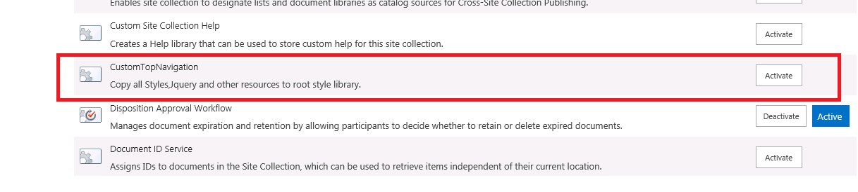 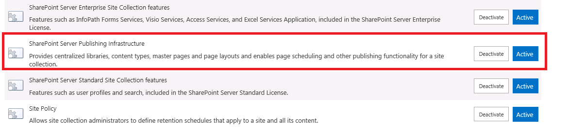

Step 3:

* Go to site setting for each site in which you want to apply Navigation.
* Go to **“Manage Site Feature”**.
* Activate “**Sharepoint Server Publishing**”

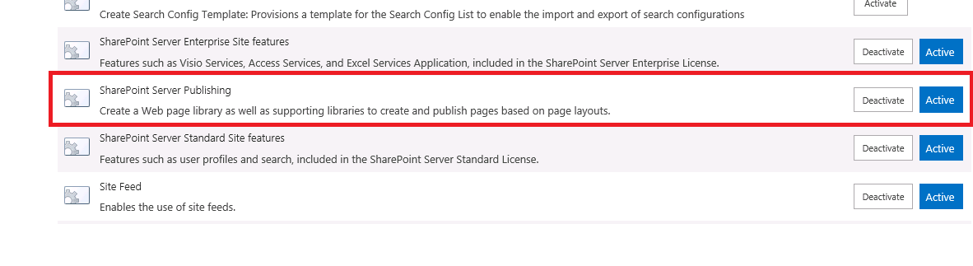

* Activate **“Mega Menu Flyout”** feature.

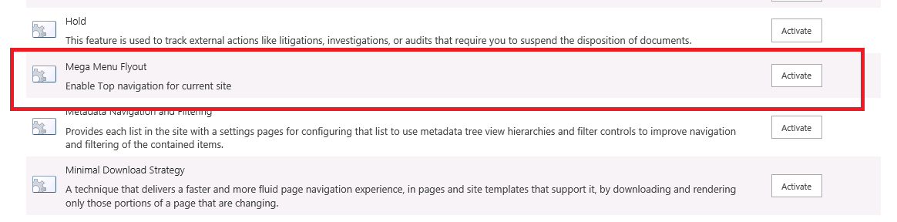

Step 4:

* Go to site Content
* Open **“TopNavigationMenu”** list.
* And remove two columns Parent and Image and add it again as per previous deployment guideline.
* After that open any publishing pages menu effect will be applied.
* We have set master page only for Site master page not for System pages so it will not displayed in system pages.

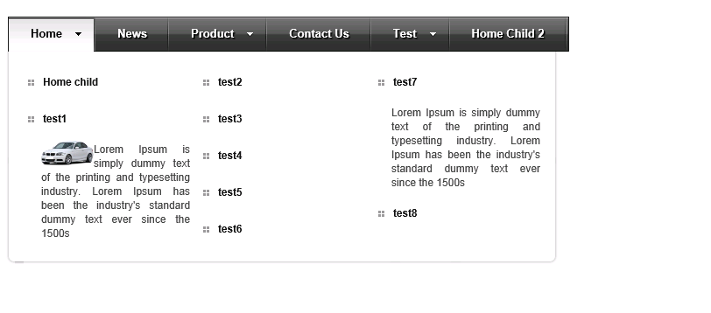

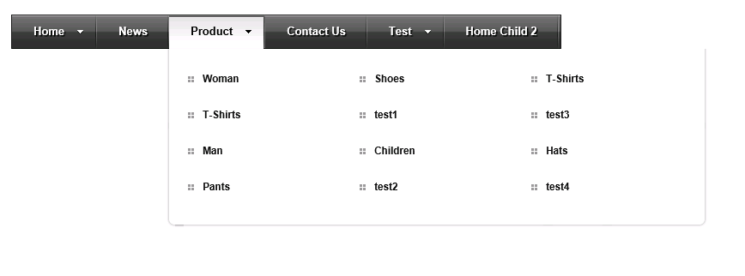

Remove Sample Data from “TopNavigationMenu” List and add proper data in it.

Example.

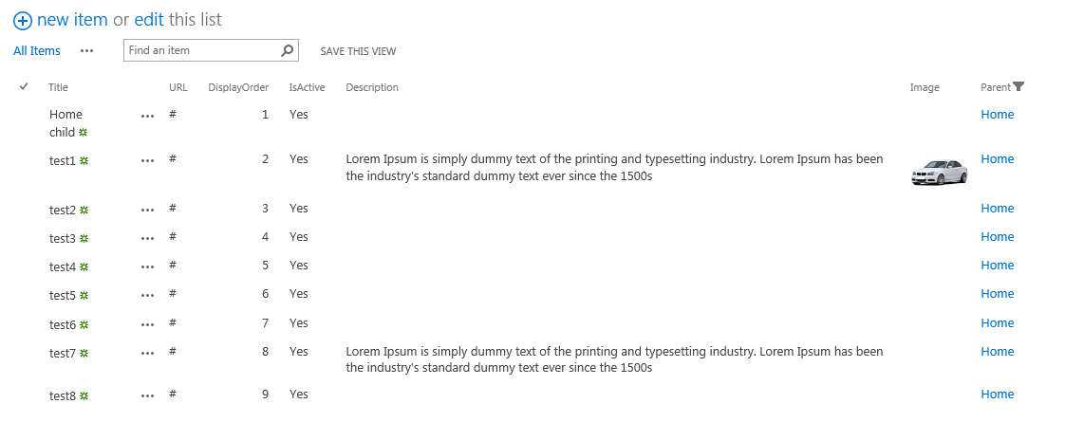

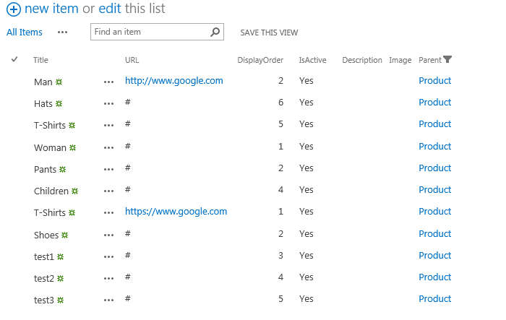

In this demo we have set menu to two level. We have set **three columns** that is defined in **STYLE.CSS**

Reside in Root style library. You can set as you want.

